An Improved Piecewise Approximation Algorithm for Image Compression
Joseph Modayil, Howard Cheng, and Xiaobo Li
Pattern Recognition, Vol. 31, No. 8, pp. 1179-1190, 1998
Abstract
One-dimensional lossy compression scheme, such as piecewise approximation with triggers (PAT) has the advantage of being computationally simple. This paper adds new features and also incorporates some ideas from previous papers to arrive at a modified version: MPAT.
- Introduction
A one-dimensional image compression algorithm has two parts−the image is scanned into a one-dimensional array and then the resulting array is compression.
- Piecewise Approximation with Triggers
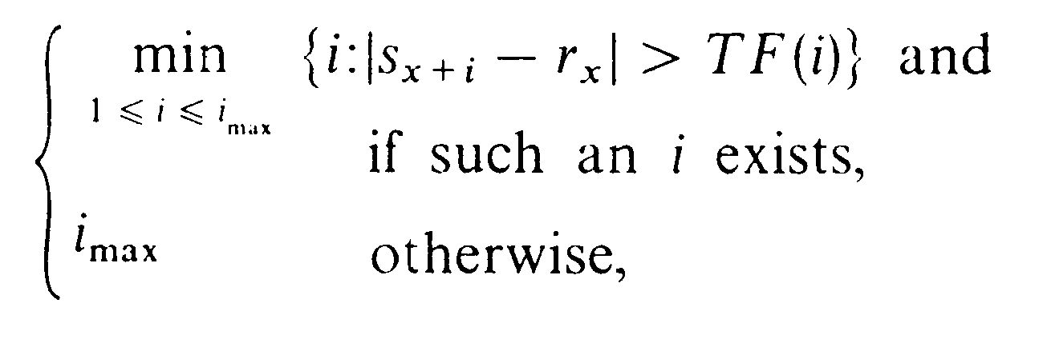

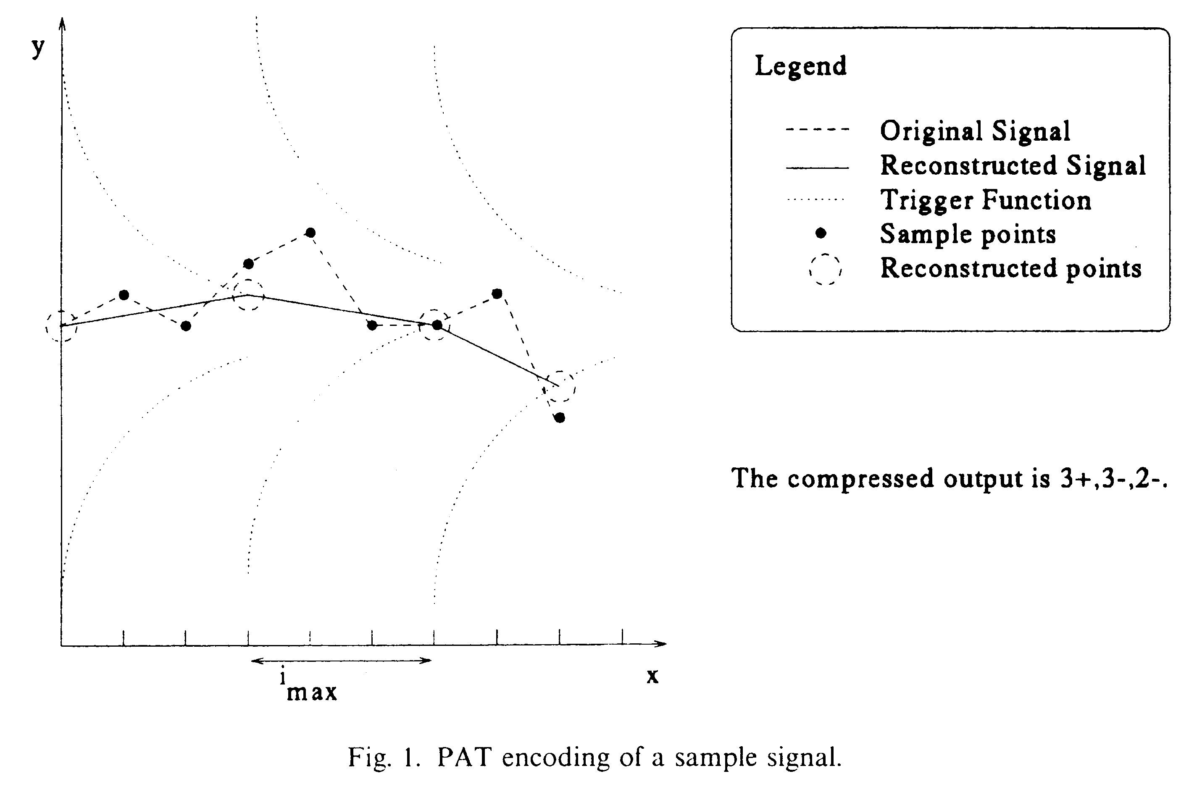
- Modified PAT (MPAT)
We propose the following changes to PAT.
• Trigger function:
TF(x) = ae^{bx}+c
• Threshold:
To avoid degradation of sharp edges in a signal.
• Context modeling:
due to computational cost
• Interpolation method:
Flat, Linear, and Quadratic interpolation
• Early trigger:
- Performance Evaluation

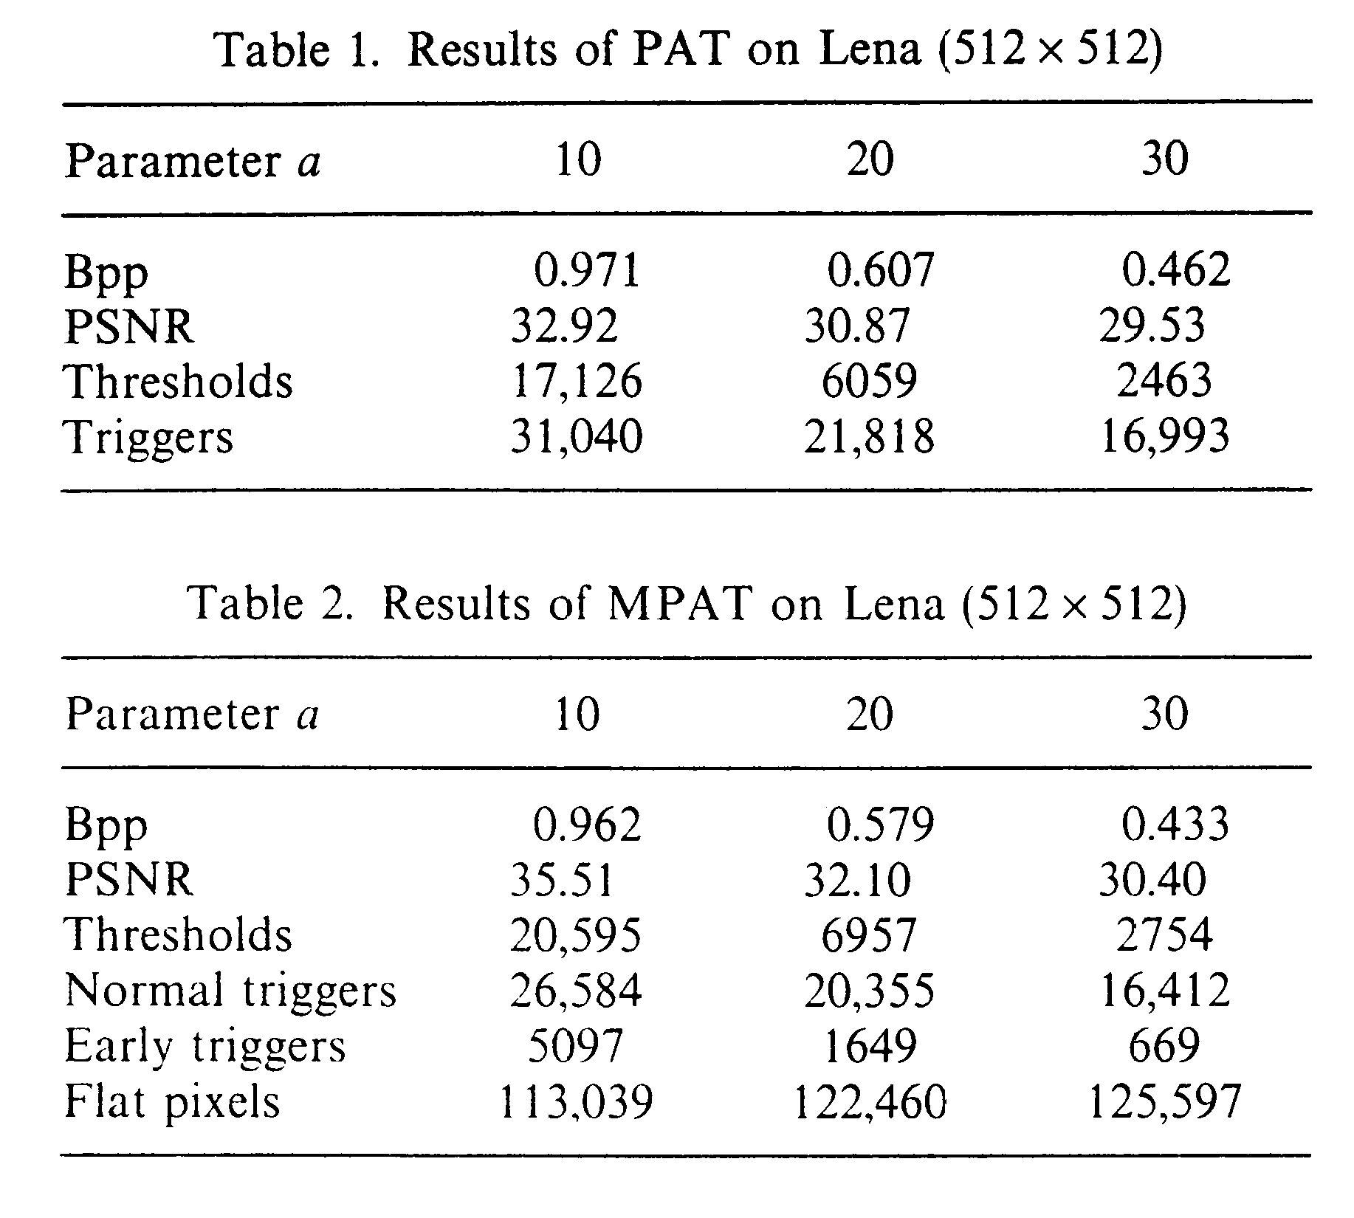
- Conclusion

Created by : Chia-Hao Yang
Date : Oct. 8, 1998

